**Kol simcha torah gazette**

**For yom kippur 5784**

Volume 8 Issue 3 (Whole #361) 10 Tishrei 5783/ September 25, 2023

**Printed L’illuy nishmas Nechama bas R’ Noach, a”h**

For a free subscription, please forward your request to [***keren18@juno.com***](mailto:keren18@juno.com)

**Three Ways to Make Yom Kippur Meaningful**

***How to embrace the opportunity of Yom Kippur and use it to truly change.***

**By**[**Slovie Jungreis-Wolff**](https://aish.com/authors/48869087)



**Here are three ways to tap into the transformational power of Yom Kippur.**

**1. Make yourself vulnerable**.

Yom Kippur is a day unlike any other. The energy of the day is [the power of *teshuvah*](https://aish.com/we-can-change/) – returning to become the person you were created to be. One of the most painful moments a human being can have is the realization that “I’ve messed up my life. I haven’t changed. The same things trigger me. I still lose it with the people I love. I haven’t grown spiritually. What’s my life about? Why am I here? What defines me?”

Think about it. After you strip away all the externals – your home, your favorite possessions, your bank account – who are you?

You have been given a personal mission to bring your unique magic into the world. Yom Kippur is the time to contemplate your life and honestly evaluate how much you are maximizing your potential.

**Reflecting on the Damage that Your Words Have Caused Others**

On Yom Kippur you recite the prayer of *[vidui](https://aish.com/a-relatable-translation-of-the-viduy-confession/)*[-confession](https://aish.com/a-relatable-translation-of-the-viduy-confession/). You stand humbled as you list a variety of behaviors for which you ask forgiveness. Many of your words enumerate transgressions you’ve done causing pain to others. You admit that you have lied. You have slandered. You have stolen – not only money, but people’s time, their sense of inner peace, their pride. You have used our gift of speech to bring others down.

As you recite *vidui*, think about adding your own personal confessions for deeds done that you now regret.

If you genuinely want to actualize the day, begin by making yourself vulnerable. Try to come into the day by seeking forgiveness from those you have wounded. Especially the people in your life that you have taken for granted and so they are most convenient to hurt. No more blaming others for your shortcomings. It’s not about your dysfunctional childhood, your high school cliques, your spouse, or your boss at work. It’s about accepting responsibility for the type of person you have become. You create your destiny. You write the story of your life.

**Yom Kippur calls out: “Realize your purpose because there is only one of you in all of time.”**

**2. Make yourself holy.**

This is the day to discover your soul. Within you is a Divine spark, a flicker of holiness. On Yom Kippur it is possible to ignite the fire within. Taste the spiritual and let go of the physical. We do not eat or drink, wear leather shoes, wash, anoint ourselves with perfumes, or engage in physical intimacy. It is a custom to wear white. On this day, you are pure as the angels.

Yom Kippur is a day of miracles. Perhaps we have sullied our souls. There is a layer of grime and many spiritual stains that have dulled your inner light. But if you desire to begin anew, nothing can stand in your way.

On Yom Kippur you stand in prayer before God and speak intimately of your hopes, your fears, and your dreams. You strengthen your relationship with your Creator. You transform yourself into an ambassador of light and love in this world. You become spiritual through reflecting God’s light. Every time you extend yourself and open your hearts to others, you become partners with God and become a sacred being.

**Yom Kippur calls out: “Take the holiness of the day with you throughout the year. Be a spiritual seeker. Reflect God’s light and kindness in this world.”**

**3. Make yourself grow.**

To be alive means that you are constantly growing.” Some people walk through life a a zombie state. It is not enough to pray not to die – you must also pray to live life to the max. How do you fill your days? How do you spend your time?

For Yom Kippur to matter, you need to realize that you are accountable for your days. There is a reason that so many are grappling with unease and anxiety. Instead of looking inward so many put their time into external projections. They spend hours comparing lives on Instagram, growing unhappier with their own lives and then wondering why.

Lacking growth, living with emptiness, they are left with a void inside that refuses to disappear.

You have the choice to connect to emptiness or meaning, transience or the transcendental. You have the ability to tap into timeless spiritual wisdom. Each week you can put aside the stress and savor the beauty of Shabbat. One smile, one good word can change another person’s life. Judaism provides a path to transformation – yourself, your relationships, and the world you live in.

**Yom Kippur calls out: “Take a small step. Set a goal. Make a plan. How will you grow this year?”**

This [Yom Kippur](https://aish.com/yom-kippur/), leave behind the negativity, the fear, the lack of inspiration. See the opportunity of this awesome day. Discover the fire within your soul.

**More About The Author - Slovie Jungreis-Wolff**

Slovie Jungreis Wolff is a noted teacher, author, relationships and parenting lecturer. She is the leader of Hineni Couples and daughter of Rebbetzen Esther Jungreis. Slovie is the author of the parenting handbook, Raising A Child With Soul. She gives weekly classes and has lectured throughout the U.S.,Canada, Mexico, Panama, and South Africa. You can reach slovie at [**sloviehineni@gmail.com**](mailto:sloviehineni@gmail.com) Slovie's most recent book is [**The Soul of Parenting**](https://mosaicapress.com/product/the-soul-of-parenting/), published by Mosaica Press.

*Reprinted from the September 7, 2023 website of The Jewish Press.*

**The Jew’s Challenge to Reach**

**A Higher Level of Teshuva**

**From the Teachings of the Lubavitcher Rebbe**

**Rabbi Menachem Mendel Schneerson, Zt”l**

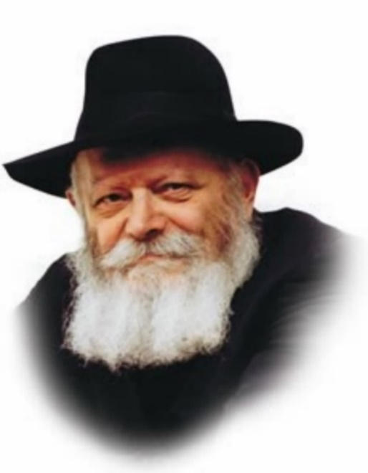

Yom Kippur, the Day of Atonement, is a day that is entirely dedicated to returning to G-d in teshuva (repentance). Among the many mitzvot involved in teshuva is the act of confession, as the Torah states, "You shall confess your sin." Indeed, this is the basis for the "Al Cheit" ("For the Sin of...") confessional recited on Yom Kippur, which enumerates the various sins a person may have committed.

In the Jerusalem Talmud, the question of whether or not this generalized confession is sufficient is debated. Rabbi Yehuda Ben Betaira maintains that in addition to reciting "Al Cheit," a detailed admission of personal sins is required. Rabbi Akiva, by contrast, opines that "It is not necessary to go into detail about one's deeds."

But what exactly is the crux of their argument? As the Tosefot explains, Rabbi Yehuda's insistence on a detailed account is for the purpose of arousing a deeper sense of remorse. The more a person is ashamed of his misdeeds, the deeper his repentance will be.

Rabbi Akiva, however, takes the human factor into consideration, and asserts that if a person's individualized confession is overheard by others, "he might be suspected of other sins as well." In other words, the way people think about him might be negatively affected.

In essence, the argument revolves around where the emphasis should be placed: on the present, or on the future. When the present is emphasized - the fact that today is Yom Kippur - it is preferable to enumerate one's sins in order to achieve a higher level of teshuva. When the stress is on the future, the determining factor is to avoid any possible negative repercussions.

On a deeper level, there is another basis for their disagreement. Rabbi Yehuda views the individual in his present state, as one who is just beginning to do teshuva and draw closer to G-d. There are two basic motivations for doing teshuva: an initial stage, in which a person repents out of a sense of fear, and a higher level, on which the motivation is love for G-d. When a person enumerates his every little sin, it produces in him a stronger feeling of fear and awe of G-d.

Rabbi Akiva, however, looks at the larger picture, and anticipates that the person will eventually reach the higher level. In fact, his entire approach is to always perceive the hidden good in everything. When a person repents out of love for G-d, it makes no difference whether the sin is great or small; for he knows that every sin creates a distance between himself and G-d, and he will avoid committing even the smallest transgression.

*Reprinted from the Parshas Ha’azinu 5761/2000 edition of L’Chaim. (Adapted from Volume 24 of Likutei Sichot.)*

**Rav Avigdor Miller on**

**Pre- Yom Kippur Plans**

**QUESTION:** What should be the first thing one should correct before Yom Kippur?

**ANSWER:** To be facetious, I'll say the first thing is to correct yourself. But, of course you'll ask, “But in myself, what's the first thing?”

The very first thing you must do is to make sure that all the wrongs that you committed against your fellow man are righted. Other things could perhaps be rectified during Yom Kippur – for many things you can do teshuva on Yom Kippur – but if somebody has an outstanding complaint against you, then you have to realize nothing is going to help until you get forgiveness from that person. אין יום כיפור מכפר עד שירצה את חבירו. That’s why it’s so important to learn to say, “Forgive me.” And don't wait for Yom Kippur.

The am ha'aretz doesn't do that. The am ha'aretz insults people and never thinks to beg forgiveness. The talmid chochom on the other hand is always careful with people, but if he does step on somebody's feet, he is quick to admit the error and ask forgiveness. So, it should be a habit constantly to be asking people to forgive you.

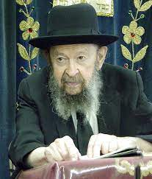

Now, really it’s a small matter to get forgiveness because most people are willing to yield once they see you are contrite, but you have to ask for it. Even calling up on the telephone is worthwhile; and it should be done to as many people as possible with whom you had dealings with if there’s the slightest suspicion that you wronged them in any way. That's the number one requirement before Yom Kippur.

*Excerpted from an email of Toras Avigdor based on Rabbi Avigdor Miller’s Tape #568 (September 1985) from his classic Thursday night lectures.*

**The Kaparot Ceremony**

***The Day Before Yom Kippur: An Overview of Observances***

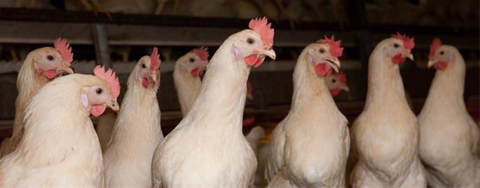

**What Is Kaparot?**

Since late Talmudic times, it has been a widespread Jewish custom to perform *kaparot* in preparation for Yom Kippur. *Kaparot* (also spelled *kapparot* or *kaporos*) literally means “atonements,” just as [*Yom Kippur*](https://www.chabad.org/library/article_cdo/aid/4687/jewish/Yom-Kippur.htm) means “the Day of Atonement.” *Kaparot* consists of carefully (see instructions below) passing a chicken over one’s head three times while reciting the appropriate text. The chicken is then slaughtered in a humane fashion in accordance with the laws of kashrut. The chicken itself is discreetly donated to a charitable cause, such as a yeshiva or orphanage, where it is eaten just as any other chicken. Alternatively, the chicken is sold and its value donated.[1](javascript:doFootnote('1a989585');)

We ask of G‑d that if we were destined to be the recipients of harsh decrees in the new year, may they be transferred to this chicken in the merit of this mitzvah of charity.

If a chicken is unavailable, one may use any kosher fowl other than doves or pigeons which were offered as sacrifices in the Holy Temple. Some use a live [kosher](https://www.chabad.org/library/article_cdo/aid/113424/jewish/Kosher.htm) fish; others perform the entire rite with money, and then give the money—at least the value of a chicken—to charity.

It is important to keep in mind that the chicken is not an offering. Neither does performance of the ceremony alone atone for one’s sins. However, the ceremony does shake one up a little.

This is especially true today, when we rarely come face-to-face with the slaughter of animals to fill our tables. Holding a chicken and then seeing it slaughtered, contemplating that “there but for the grace of [G‑d](https://www.chabad.org/library/article_cdo/aid/433240/jewish/God.htm) go I,” can have a profound effect on one’s attitude going into the day of Yom Kippur.

It also provides a valuable perspective on our position of privilege in G‑d’s world. Animals lived and died in order for us to live. It behooves us to live altruistically, honestly, devoutly and wisely, as only humans can.

**When to Do Kaparot**

In most Jewish communities, *kaparot* is organized at a designated location, with the proceeds going to charity. Live chickens are available for purchase, a *shochet* (an expert kosher slaughterer) is present, and the chickens are donated to a charitable organization. Speak to your rabbi to find out whether and where *kaparot* is being organized in your area.

*Kaparot* can be done any time during the Ten Days of Repentance (i.e. between Rosh Hashanah and Yom Kippur), but the ideal time is during the pre-dawn hours on the day preceding Yom Kippur, for a "thread of Divine kindness" prevails during those hours.

**How Many Chickens?**

A male takes a rooster; a female uses a hen. Ideally every individual should use their own chicken.

If, however, this is cost prohibitive, one fowl can be used for several individuals. So an entire family can do *kaparot* with two chickens—one rooster for all the males and one hen for all the females. In this event, they should do the *kaparot* together, not one after the other, for one cannot do *kaparot* on the same chicken twice.

A pregnant woman should perform *kaparot* with three chickens—two hens and a rooster. One hen for herself, and the other hen and rooster for the unborn child (if the gender is undetermined). If this is too expensive, one hen and one rooster will suffice (and if the fetus is female, she shares the hen with her mother).

**How to Do Kaparot**

[Click here](https://www.chabad.org/library/article_cdo/aid/320228/jewish/Text-of-Kapparot.htm) for the English text of the *kaparot*. [Click here](https://www.chabad.org/media/pdf/339/eOux3393298.pdf) for Hebrew and English text in printable PDF format (courtesy of Kehot Publication Society).

Hold the chicken from below with both hands. If you are not adept at holding a chicken, best to ask someone else to do this. Improperly holding the chicken may be painful to the chicken, and may also render it no longer kosher by causing it serious harm.

Say the first paragraph (“Children of man who sit in darkness…”).

When reciting the beginning of the second paragraph, pass the chicken over your head in circular motions three times—once when saying, “This is my exchange,” again when saying “This is my substitute,” and again when saying, “This is my expiation.”

Repeat the entire process another two times. (Passing the chicken over your head a total of nine times.)

Bring the chicken to the [*shochet*](https://www.chabad.org/library/article_cdo/aid/222243/jewish/Can-Anyone-Perform-Shechita.htm) (kosher slaughterer), who slaughters the bird.

Here’s your chance to fulfill a relatively rare biblical [mitzvah](https://www.chabad.org/library/article_cdo/aid/1438516/jewish/Mitzvah.htm)—that of [covering the blood of a slaughtered](https://www.chabad.org/library/article_cdo/aid/559491/jewish/Why-Cover-the-Blood-of-a-Slaughtered-Animal.htm) [bird](https://www.chabad.org/library/article_cdo/aid/559491/jewish/Why-Cover-the-Blood-of-a-Slaughtered-Animal.htm). Take a handful of earth (usually made available in the area) and recite the following blessing before covering the blood:

*Baruch atah Adonai Eloheinu melech ha-olam, asher kidishanu bemitzvotav vetzivanu al kisui hadam be-afar.*

(Blessed are You, L‑rd our G‑d, King of the universe, who has sanctified us with His commandments and commanded us concerning covering the blood with earth.).

It is customary in many communities to tip the *shochet* for his service.

Even the smallest of children are traditionally brought to *kaparot*, and one of the parents passes the chicken over the child's head, while saying, “This is your exchange, this is your substitute, this is your expiation…”

If you are using fish or money for *kaparot,* just follow the same procedure (obviously without the kosher slaughterer), modifying the words of the text as appropriate.

**Origin of Kaparot**

The custom of performing *kaparot* with a chicken dates back to late Talmudic times. The earliest extant record specifically discussing the use of a chicken is a responsum from Rav Sheshna Gaon who lived in the early Geonic (post-Talmudic) period (approx. 660 C.E.). Rav Sheshna takes it for granted that his reader knows about the custom, a clear indication that it was widespread at the time.[2](javascript:doFootnote('2a989585');) Some commentaries point to passages in the Talmud itself that allude to this custom.[3](javascript:doFootnote('3a989585');)

**Why a Chicken?**

Several reasons have been suggested for the choice of a chicken to perform the *kaparot* rite:

**1.** In Aramaic, a rooster is known as a *gever.* In Hebrew, a *gever* is a man. Thus, we take a *gever* to atone for a *gever.*

**2.** A chicken is a commonly found fowl and relatively inexpensive.

**3.** It is not a species that was eligible to be offered as a sacrifice in the Holy Temple. This precludes the possibility that someone might erroneously conclude that the *kaparot* is an offering.

It is customary to use a white chicken, to recall the verse ([Isaiah 1:18)](https://www.chabad.org/15932#v18), "If your sins prove to be like crimson, they will become white as snow." In any event, one should not use a black chicken, as black is the color that represents divine severity and discipline. Nor should one use an obviously blemished chicken.

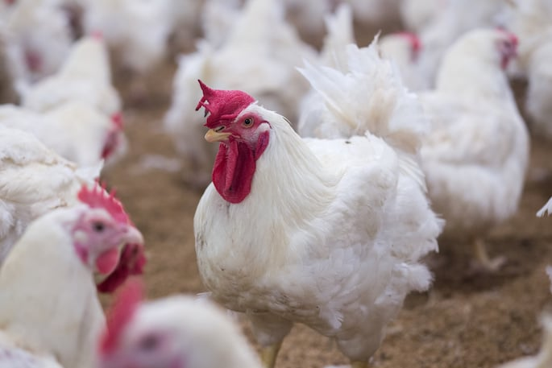

**The Detractors**

There have been some rabbis who criticized the custom of *kaparot*. Their primary concern was that *kaparot* may be a violation of *darchei ha-Emori*, the prohibition of following pagan practices. Perhaps the most well-known of the detractors was [Rabbi Yosef Karo](https://www.chabad.org/library/article_cdo/aid/380611/jewish/Rabbi-Yosef-Joseph-Caro-The-Master.htm), compiler of the Code of Jewish Law.[4](javascript:doFootnote('4a989585');)

Despite their concerns, we find that the majority of Jewish communities—even among the Sephardim, who normally would follow the rulings of Rabbi Yosef Karo[5](javascript:doFootnote('5a989585');) —retained the custom.

The reasons for this is that, as [Rabbi Moshe Isserles](https://www.chabad.org/library/article_cdo/aid/111847/jewish/Rabbi-Moshe-Isserles-The-Remo.htm) notes,[6](javascript:doFootnote('6a989585');) the custom of *kaparot* with a chicken is in fact an ancient time-hallowed Jewish tradition.

Furthermore, many rabbis explain that the concern was not about the *kaparot* ritual itself, but limited to certain components of it—either that people went out of their way to obtain white chickens,[7](javascript:doFootnote('7a989585');) or that they would throw the innards on the roofs.[8](javascript:doFootnote('8a989585');)

Additionally, Rabbi David ibn Zimra (Radbaz) points out that their objection was also only when the proceeds and/or chickens were not given to charity.[9](javascript:doFootnote('9a989585');)

**Kaparot and Kindness to Animals**

It is of utmost importance to treat the chickens humanely, and not to, G‑d forbid, cause them any pain or discomfort. Jewish law very clearly forbids causing any unnecessary pain to any of G‑d's creations. An unkind act like that would certainly be amplified on this day, the eve of the day when we beseech G‑d for—perhaps undeserved—kindness and mercy.

In fact, the [Code of Jewish Law](https://www.chabad.org/library/article_cdo/aid/4305141/jewish/14-Facts-About-the-Code-of-Jewish-Law-Shulchan-Aruch.htm) suggests that we take the innards and liver of the *kaparot* chickens and place them in an area where birds can feed off them. “It is proper to show mercy to the creatures on this day, so that in Heaven they should have mercy upon us [too].”[10](javascript:doFootnote('10a989585');)

**FOOTNOTES**

[1.](https://www.chabad.org/library/article_cdo/aid/989585/jewish/Kaparot.htm" \l "footnoteRef1a989585) Shulchan Aruch Harav, Orach Chaim 605:4.

[2.](https://www.chabad.org/library/article_cdo/aid/989585/jewish/Kaparot.htm" \l "footnoteRef2a989585) See Otzar Hageonim, Yoma 216;[Teshuvot Hageonim, Shaarei Teshuva 299](http://chabadlibrarybooks.com/pdfpager.aspx?req=30774&st=&pgnum=69), Orach Chaim 299; See also Tur Orach Chaim, 605 where the custom is mentioned in the name of the Geonim.This custom is also mentioned by many later Geonim such as Rabbi Amram Gaon, Rabbi Natronai (ben Hillel) Gaon and others.

[3.](https://www.chabad.org/library/article_cdo/aid/989585/jewish/Kaparot.htm" \l "footnoteRef3a989585) See Rashi on Talmud Shabbat 81b where he quotes a Geonic letter that says “parphisa” is a basket used in a form of the *kaparot* ritual, albeit one with a basket planted with beans which was later thrown into the river (it should be noted that Rashi’s student in his Machzor Vitri writes that it was their custom to do kaparot with a chicken. See also Maharal, Netivot Olam, Netiv HaBitachon 1 where he cites the story (see Talmud Berachot 60b) of Rabbi Akiva’s rooster being eaten by a cat (which eventually saved his life). Maharal explains that the rooster’s death was actually for the good, since its life was taken in place of Rabbi Akiva’s. He states that this is “clear proof from the Talmud that a chicken should be used for an atonement of one’s life before Yom Kippur.”

[4.](https://www.chabad.org/library/article_cdo/aid/989585/jewish/Kaparot.htm" \l "footnoteRef4a989585) Rabbi Yosef Caro (1488 – 1575) in his Shulchan Aruch, Orach Chaim 605:1. Other notable detractors include Rabbi Moshe ben Nachman (Nachmanides, 1194–1270) Quoted in Orchot Chaim, Hilchot Erev Yom Kippur 1; Rabbi Shlomo Ben Aderet (Rashba, 1235–1310) in Teshuvot Harashba 1:395.

[5.](https://www.chabad.org/library/article_cdo/aid/989585/jewish/Kaparot.htm" \l "footnoteRef5a989585) See Ben Ish Chai, Parshat Vayeilech ois 2; Kaf Hachaim 605; Rabbi Ovadia Yosef, Yalkut Yosef Moadim pg 75; Rabbi Mordechai Eliyahu, Maamar Mordechai, chapter 42:1.

[6.](https://www.chabad.org/library/article_cdo/aid/989585/jewish/Kaparot.htm" \l "footnoteRef6a989585) Shulchan Aruch, Orach Chaim 605:1.

[7.](https://www.chabad.org/library/article_cdo/aid/989585/jewish/Kaparot.htm" \l "footnoteRef7a989585) See Aruch Hashulchan, Orach Chaim 606:4.

[8.](https://www.chabad.org/library/article_cdo/aid/989585/jewish/Kaparot.htm" \l "footnoteRef8a989585) Rabbi Chaim Hakohen in Tur Berekes (quoting the Mekor Chaim) 605.

[9.](https://www.chabad.org/library/article_cdo/aid/989585/jewish/Kaparot.htm" \l "footnoteRef9a989585) Responsum of the Radbaz 2:740.

[10.](https://www.chabad.org/library/article_cdo/aid/989585/jewish/Kaparot.htm" \l "footnoteRef10a989585) Tur and Shulchan Aruch Orach Chaim (Rama) 605. Tashbatz ad loc. Bayit Chadash ad loc. Turei Zahav ad loc 104. Shulchan Aruch HaRav 605:6.

*Reprinted from the Chabad.Org Yom Kippur website.*